**

## Building a Student Internship and Job Opportunity Platform using Flask

# group k flask Project report

### Version <1.0>

### 6th august 2023

**COURSE CODE & NAME:** BSE2301 SOFTWARE ENGINEERING MINI PROJECT 2

**GROUP:** K

**SUPERVISOR:** Dr. RUTH MBABAZI

**GitHub Link: https://github.com/Leelyhane/Group-K-Flask-Project**

|  |  |  |
| --- | --- | --- |
| **NAME** | **REGISTRATION NUMBER** | **STUDENT NUMBER** |
| NABISUBI LILLIAN PROSSY | 21/U/09609/PS | 2100709609 |
| BAHEBWA RASHIDAH ADYEERI | 21/U/23336/EVE | 2100723336 |
| KIRUMIRA BENJAMIN EDWARD | 21/U/05106/PS | 2100705106 |
| KIKOMEKO BASHIR MUSA | 21/U/05034/PS | 2100705034 |
| LUSWATA ANDREW BRIAN | 21/U/04643/PS | 2100704643 |

**TABLE OF CONTENTS**

**1. PROJECT CLOSURE 2**

1.1 Introduction 2

1.2 Purpose 2

1.3 Objectives 2

1.4 Overview 2

1.5 2

**2. SYSTEM OVERVIEW 2**

**3. DEVELOPMENT PROCESS 2**

3.1 Database design 2

3.2 Backend development3

3.3 Front end development 3

3.4 Conclusion 4

|  |  |  |  |
| --- | --- | --- | --- |
| **Project/Program Name** | Career Bridge | | |
| **Project Supervisors** | Dr.Ruth Mbabazi  Jeff Geoff  Livingstone Ndigezza | | |
| **Project/Program Leader** | Nabisubi Lillian Prossy | | |
| **Project/Program collaborators** | Bahebwa Rashidah Adyeeri  Kikomeko Bashir Musa  Kirumira Benjamin Edward  Luswata Andrew Brian | | |
| **Start Date** | 24th July 2023 | **Completion Date** | 9th August 2023 |

# Part 1: Project Closure

## INTRODUCTION

In today's competitive job market, students often struggle to find relevant internship and job opportunities. This project aims to bridge this gap by developing a user-friendly platform that connects students with various internship and job listings. The platform enables students to submit their resumes and view available internship and job opportunities, making their internship and job search process more efficient and targeted.

## PURPOSE OF THE PROJECT

This report presents the development of Career Bridge, a web application aimed at connecting students with internship and job opportunities. The platform allows students to submit their resumes and view a curated list of available job listings. The application was built using the Flask web framework, providing a user-friendly interface and efficient data handling. This report outlines the project's objectives, the technology stack used, the development process, and key features of the final application..

## OBJECTIVES

* **Connect Students with Opportunities:** The primary objective of this project is to create a platform that seamlessly connects students with relevant internship and job opportunities. By providing a centralized hub for job listings, students can easily discover positions that match their skills and interests.
* **Efficient Job Search:** The platform aims to streamline the job search process for students. They can search for opportunities based on various filters such as industry, location, job type, and more. This helps students narrow down their search and find opportunities that align with their preferences.
* **Resume Submission:** Enabling students to submit their resumes directly through the platform eliminates the need for redundant data entry when applying for multiple positions. This feature enhances efficiency and simplifies the application process.
* **User-friendly Interface:** The project strives to create an intuitive and user-friendly interface. The design focuses on providing easy navigation, clear information display, and a seamless user experience for both job seekers and employers.
* **Personalized Experience:** The platform aims to provide a personalized experience for each user. Through features like user profiles and recommended job listings, the project seeks to tailor the platform to individual preferences and career goals.
* **Security and Privacy:** Ensuring the security of user data and maintaining their privacy is a fundamental objective. The project aims to implement robust security measures to protect user information, including encryption and secure authentication methods.

By achieving these objectives, the Student Internship and Job Opportunity Platform will provide students with a powerful tool to navigate their career paths, while also benefiting employers by connecting them with a pool of talented and motivated individuals.

## Overview

This report presents the development of Career Bridge, a web application aimed at connecting students with internship and job opportunities. The platform allows students to submit their resumes and view a curated list of available job listings. The application was built using the Flask web framework, providing a user-friendly interface and efficient data handling. This report outlines the project's objectives, the technology stack used, the development process, and key features of the final application.

**TECHNOLOGY STACK**

Career Bridge was built using the following technology stack:

1. **Python**: The primary programming language for backend development.
2. **Flask**: A lightweight and flexible web framework for python.
3. **SQLite**: A relational database management system used to store user data, internship listings, job listings and resumes.
4. **HTML/CSS**: For front-end user interface design and styling.
5. **JavaScript:** To enhance user interactivity and to provide dynamic features.

## Key features

**User Registration and Authentication:** Students can register accounts on the platform, providing their basic information. User authentication ensures secure access to the platform.

**Resume Submission:** Students can upload their resumes to their profiles, allowing them to easily apply for job opportunities without the need for repetitive data entry.

**Job Listings and internship programs:** The platform provides a curated list of internship and job opportunities from various industries. Users can filter and search for listings based on their preferences.

**User Profile:** Each user has a profile where they can manage their personal information, update their resume, and track their activity on the platform.

# Part 2: system overview

## landing page

It grabs users’ attention and guides them towards a specific conversion goal, which in this case is the ability to get job and internship opportunities.

Here users are able to know more details about the website and take a desired action such as signing up if they pick interest in the help being offered by the Career Bridge application.



Landing page 1

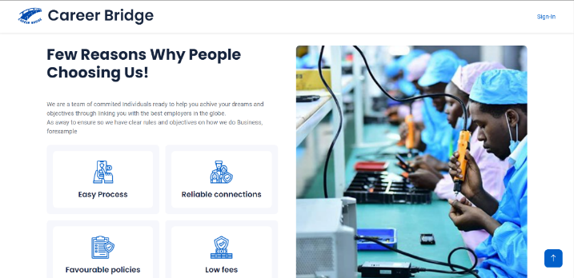

## register page

This is where new users can create accounts to access features and content of the Career Bridge website. It is a crucial component for user authentication and interaction. The required fields are a username, an email address and a password and a user is expected to input a valid email address or else they cannot proceed with registration.

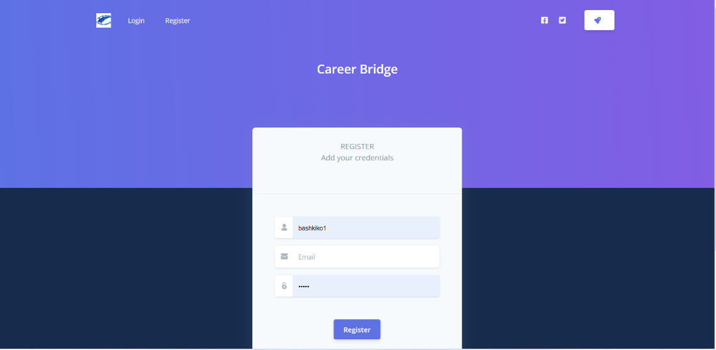

Registration page

## login page

This is a vital entry point where existing users such as students and administrators can access their accounts by simply providing their credentials. The core components are the fields where users enter their username and password.

In a case where a user inputs a wrong password, they are notified to input a right password since their usernames are usually remembered by the site.

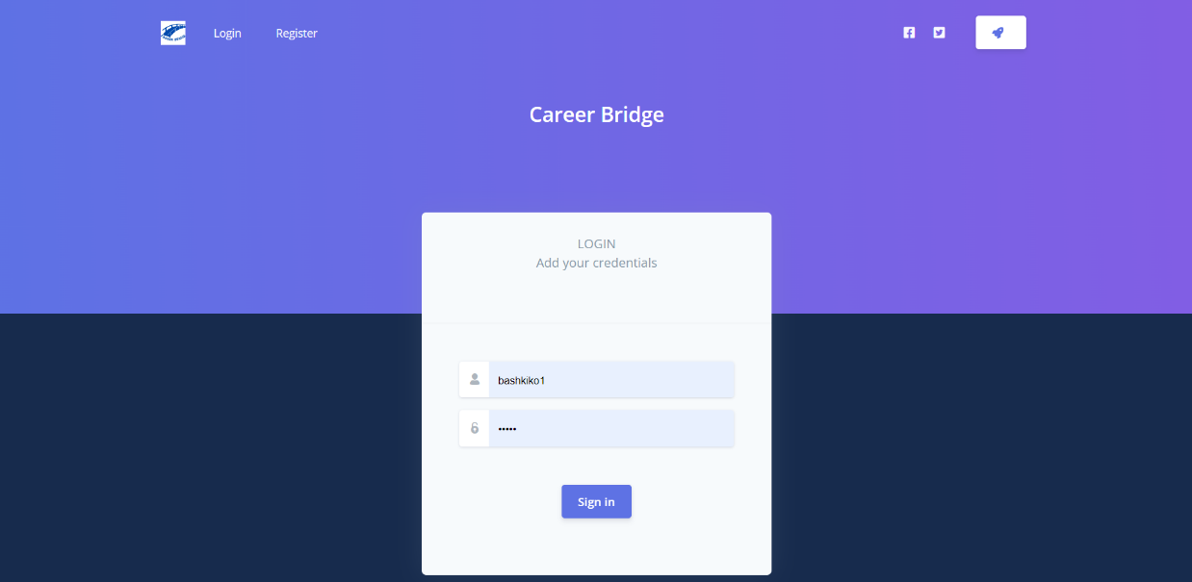

Login page

## add job and internship listings

These pages allow administrators to add new jobs or internships listings to be displayed on the website for potential candidates to view and apply.

The platform provides a curated list of internship and job opportunities from various industries. Users can filter and search for listings based on their preferences.

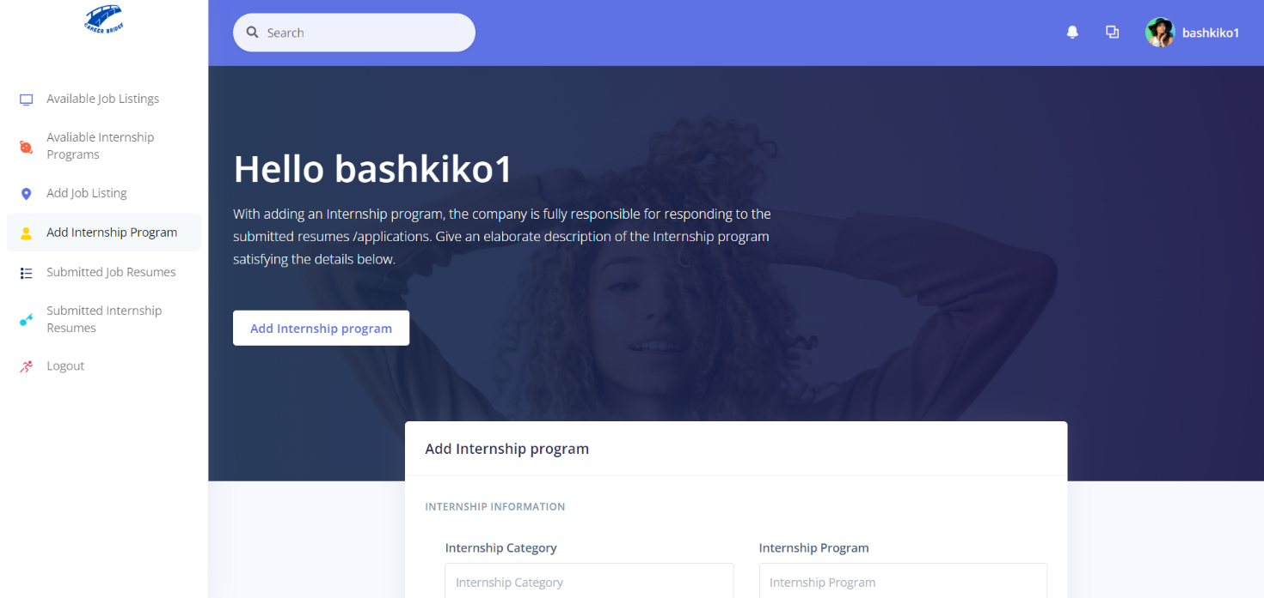

Add internship 1

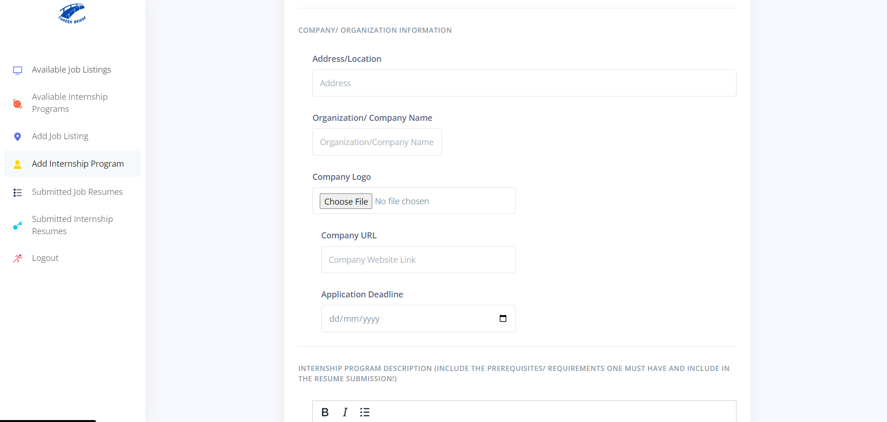

Add internship 2

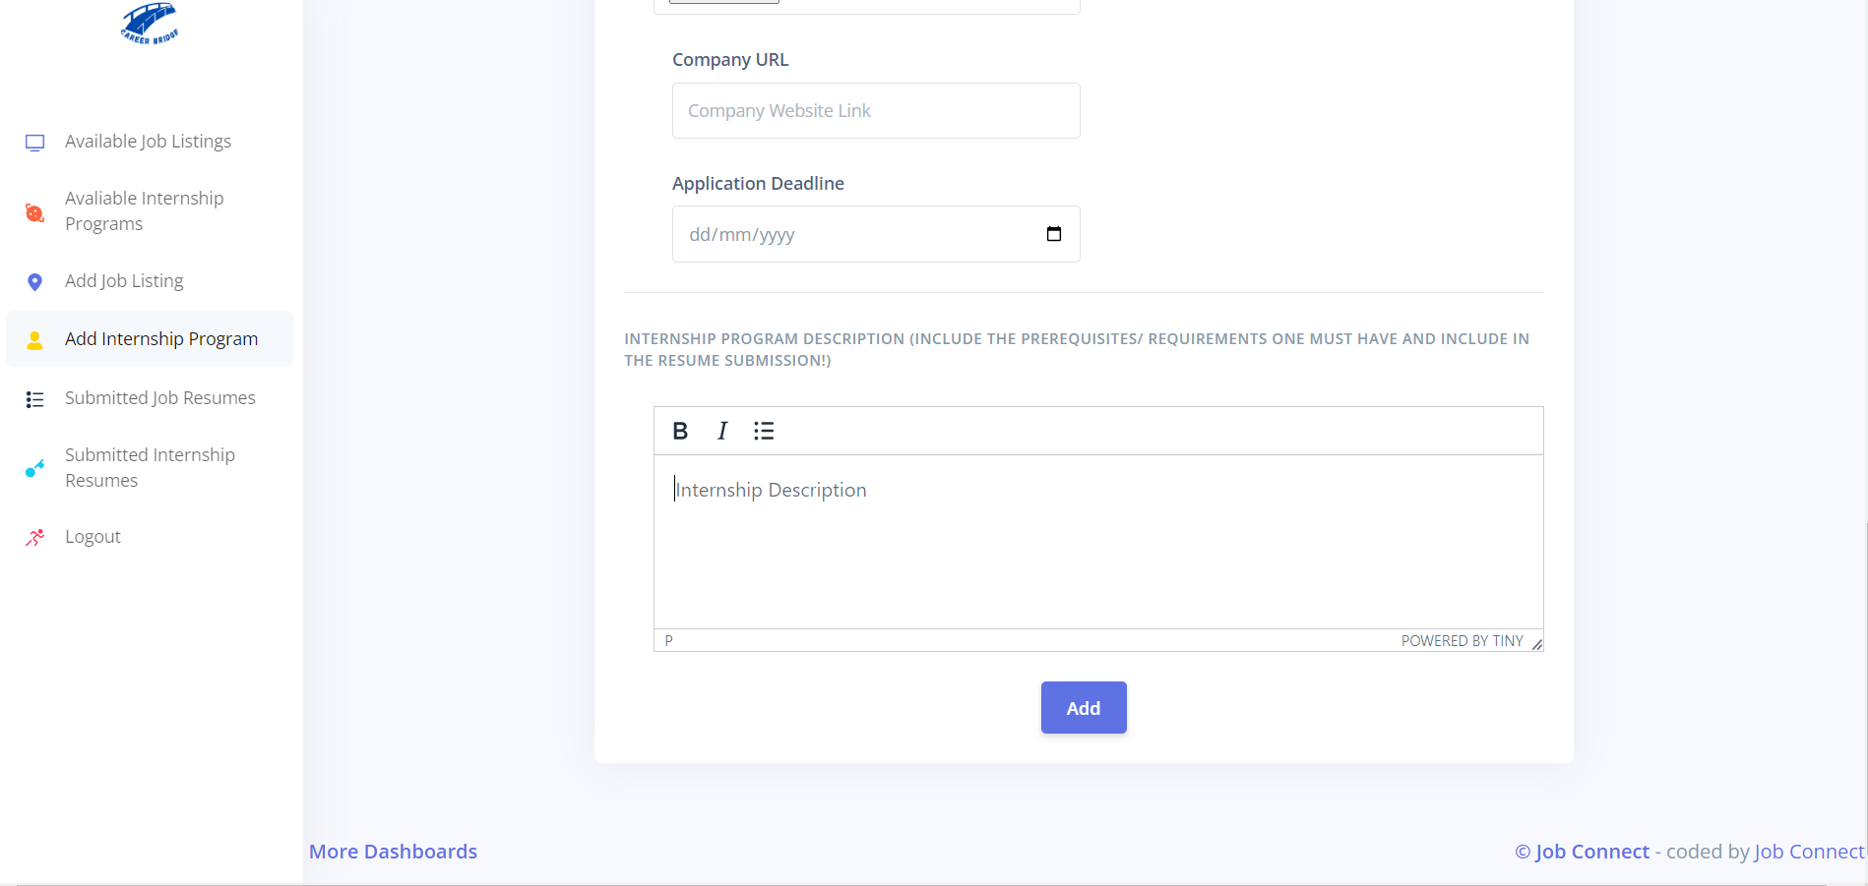

Add internship 3

## resume submission

Students can upload their resumes during time of application allowing them to easily apply for job opportunities without the need for repetitive data entry.

## AVAILABLE JOBS

This page displays the available jobs that students can apply for. These are usually added or updated by the administrators as they are the only people assigned to this duty.

Similarly, the available internship programs’ page is not any different from this as I displays the available internship opportunities that students can apply for to the various companies listed.

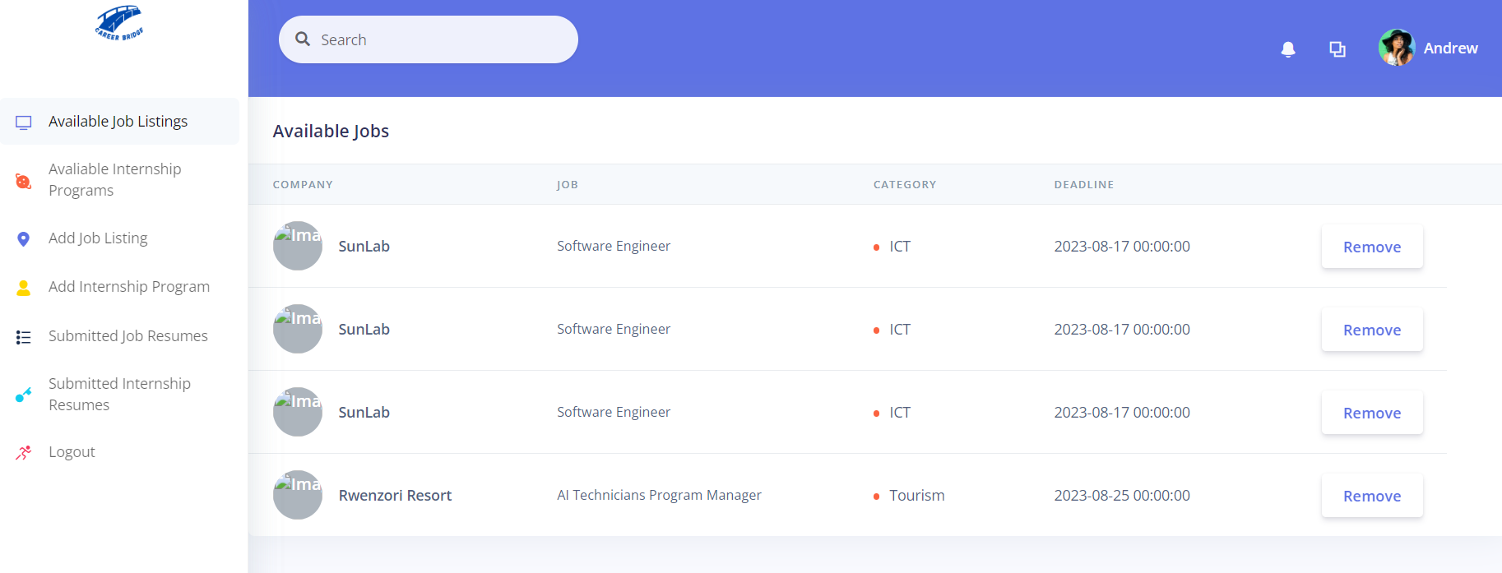

# Part 3: Development process

## DATABASE DESIGN

A database schema was designed to efficiently store user data, job listings, internship programs job resumes and intern resumes. SQLite was chosen as the database management system due to its ease of integration with Flask.

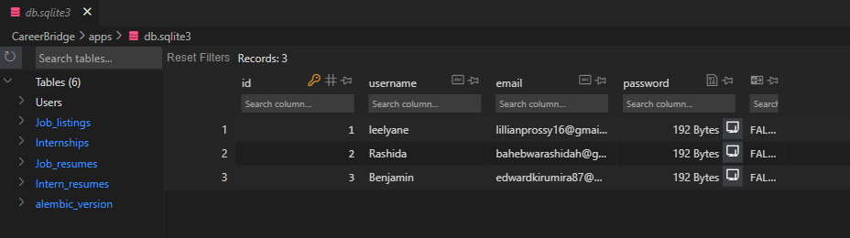

## Backend development

Using Flask, the backend of the application was developed. This included creating routes for user registration, login, resume submission, available internship programs and available job listing retrieval. Data validation and security measures have been implemented to protect user information. Below is a code snippet of the route regarding login:

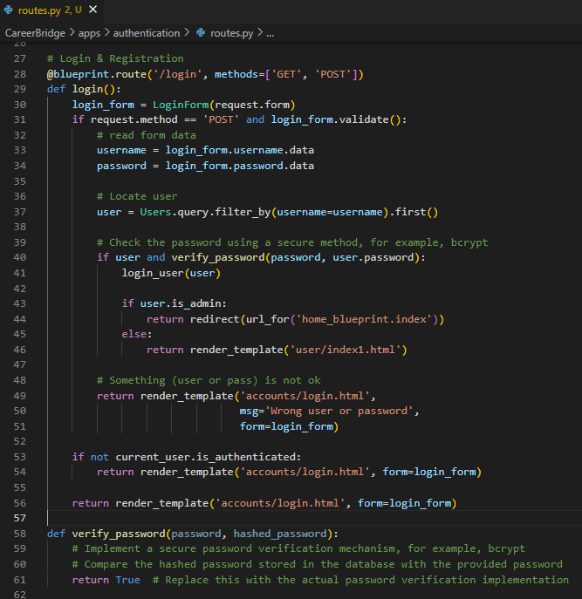

## front-end development

The front-end was developed using HTML, CSS, and JavaScript. The user interface was designed to be intuitive and responsive, providing an easy-to-navigate platform for users to interact with.

## CONCLUSION

The development of Career Bridge using Flask successfully addresses the challenge of connecting students with relevant internship and job opportunities. The platform's user-friendly interface, resume submission feature, and internship and job listing curation enhance the overall job and internship search experience for students. The project also highlights the power of Flask as a framework for building efficient and scalable web applications. Further enhancements could include integrating machine learning algorithms for personalized job recommendations and expanding the platform's reach to include more industries and regions.e more industries and regions.